Technical Design Template

Team: | Phantom | ITN: | 132345 |  |  | Solution Design
 |  | Pipeline(s): | SOLUTION_TEST
  Feature Number(s): 306189

Team: 1
ITN: 1
Solution Design 1
Pipeline(s): 1
1 Introduction 1
1.1 Link to Requirements Document 1
1.2 Requirements 1
User Story 1
2 Design Discussion 2
1.3 Use Case 2
1.4 Class Diagrams 2
3 Implementation 3
1.5 Files 3
4 Testing Considerations 5
5 Screenshots 6

Introduction
This is a web-based application used to manage the contacts for a firm. The contacts are stored in a secure location on an internal server and the user is able to log in to the system using their access details.
The user can perform CRUD operations based on the privileges provided to them by the administrator.

Link to Requirements Document
https://jira2.cerner.com/browse/DEVACDMY-5165

Requirements
.

User Story
User Story ID | MH2
Story | Add a new contact
Description | The user is able to enter new contact details which after validation can be added to the database.

Design Discussion

Use Case
The use case for this user story can be seen as give below.

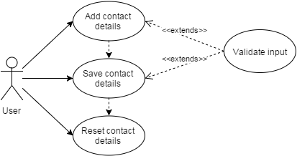

Figure 1 Use Case for adding new contact

Class Diagrams

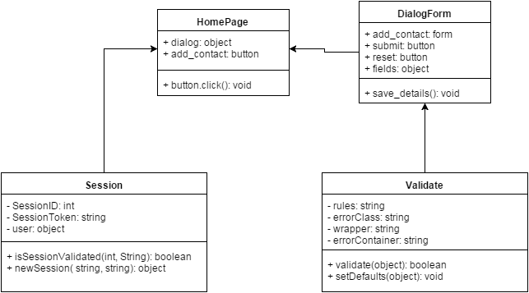
Figure 2 Class Diagram for adding contact

Implementation

This user story is to build a dialog form where the user enters the contact details to add to the database. The implementation details are as follows:

- The user can click on the add button to open a dialog form.
- The dialog form consists of fields that are mandatory and some are optional.
- The user enters the contact information using the keyboard.
- The jQuery validation plugin is used to validate the input given in the fields.
- The validation rules are as follows:
- The title, first name, last name, work contact and the email are mandatory fields while the rest are optional.
- Email address should be a valid email address.
- The work and home contact numbers should be digits and no letters.
- The date of birth should be in proper format.
- The notes field is incorporated to store any other relevant information about the person.
- The clear all button can be used to clear up all the fields and get a blank form.
- The validation functions are called upon the key up event of the keyboard and the focus out event of the html element. On clicking the submit button, the validation script is called on all the elements.
- The invalidated fields are marked with ‘error_msg’ class which is used by the css file to highlight those fields.

Files

File | home.html
Description | This is the home page where the user lands after successful authentication.It is the dashboard fir the user to add, view, update and delete contact and their details.
Pseudo Code | function checkSession(){  if ( isSet ($_POST(SessionID) & $_POST(SessionToken) )){  continueToHome();  }else{  redirectToLoginPage();  }  }
Passive (Yes/No) | No

File | css/home.css
Description | It is the css file for the “home.html” page defines the styling for the various html elements.
Passive (Yes/No) | No

File | Scripts/reformed/js/jquery.validate.js
Description | This is the javascript that receives the contact details on focus out or submit event and validates the fields according to the specified validation rules. It prevents the user to submit the data until and unless all the fields in the form are validated.
Passive (Yes/No) | Yes

Testing Considerations
Navigate to the home.html and follow the steps given below for each test case.

#Test Cases | Test Steps | Expected Results
TC 1 | - Click on the add button | A dialog window appears with a form to enter contact details.
TC 2 | - Click on the add button  - Click on the submit button | The required fields are highlighted and the user is asked to fill up these details
TC 3 | - Click on the add button  - Enter less than three characters in the first name field | An error message displays saying “Please enter atleast three characters”
TC 4 | - Click on the add button  - Enter an invalid email address | An error message displays saying “Please enter a valid email address.”
TC 5 | - Click on the add button  - Enter an invalid date in dob field | An error message displays saying “Please enter a valid date.”
TC 6 | - Click on the add button  - Enter alphabets in work contact or home contact. | An error message displays saying “Please enter only digits.”
TC 7 | - Click on the add button  - Fill up the required fields appropriately  - Click on ‘Clear all’ button | The entered details are cleared from the form

Screenshots

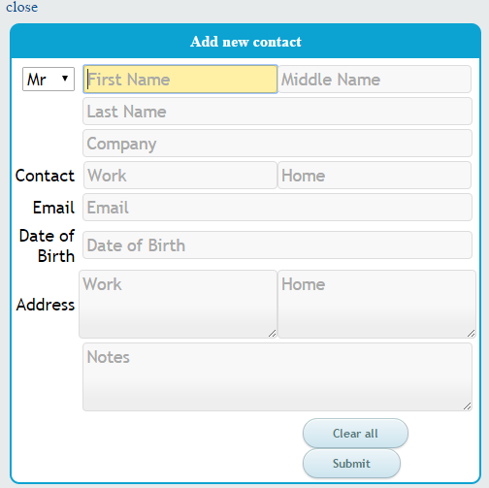
Figure 3 Dialog form to add new contact

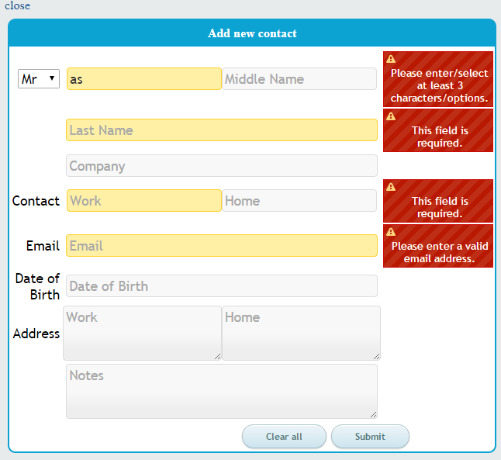
Figure 4 Validation script in action on the dialog form

